**Analysis**

**Part 1:**

1. The data indicates that the further away you move from the equator (latitude 0), the colder it gets. The data also depicts that starting at the pole’s latitude 80 and moving to -80 (towards the equator) it gets warmer

The northern hemisphere vs max temp scatter plots the data from latitude 0 to latitude 80. This is the starting point of the equator moving to the North Pole. There is a strong negative R-value -0.89 which indicates moving away from the equator it gets colder.

The northern hemisphere vs max temp scatter plots the data from latitude -80 to latitude 0. This is the starting point of the equator moving to the South Pole. There is a strong positive R- value 0.71 which indicates moving away from the south pole it gets warmer.

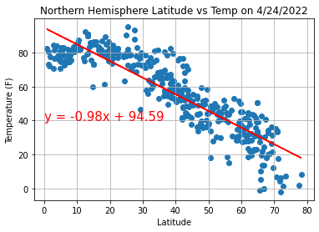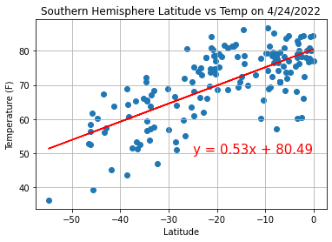

1. From the data, the latitude does not affect the level of cloudiness travelling north or south. From the Northern Hemisphere Latitude vs Cloudiness scatterplot, the R-Value is 0.18 which shows no correlation. The Southern Hemisphere Latitude vs Cloudiness scatterplot indicates that the R-Value is 0.19.

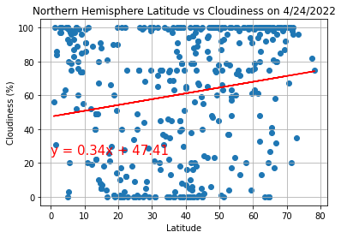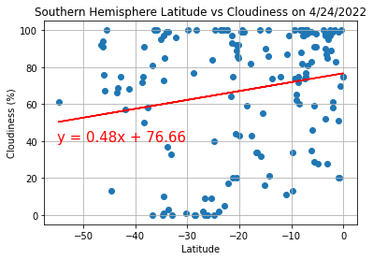

1. From the data collected the latitude does not have a strong correlation to humidity. Due to weak correlations, the further north the more humid it will be. The Northern Hemisphere Latitude vs Humidity has a R-Value of 0.27 and Southern Hemisphere Latitude vs Humidity has a R-Value 0.37. These are weak R-Values which indicates moving from -80 latitude to +80 latitude there might be more humidity.

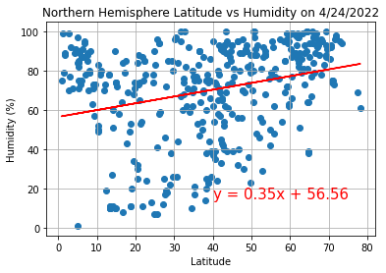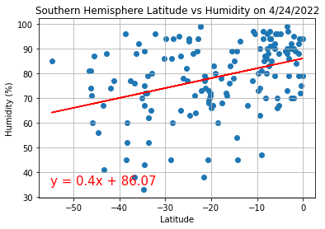

**Part 2:**

**Heat Map**